Diamond Mine Hitmen
Fall 2022 10U Baseball Open Tryouts

Dates: 6/29 & 7/6
Time: 6:00 pm
Field Location: 225 Sardis Rd. Asheville NC 28806
Rain Location: Diamond Mine 951 Sand Hill Rd, Asheville, NC 28806
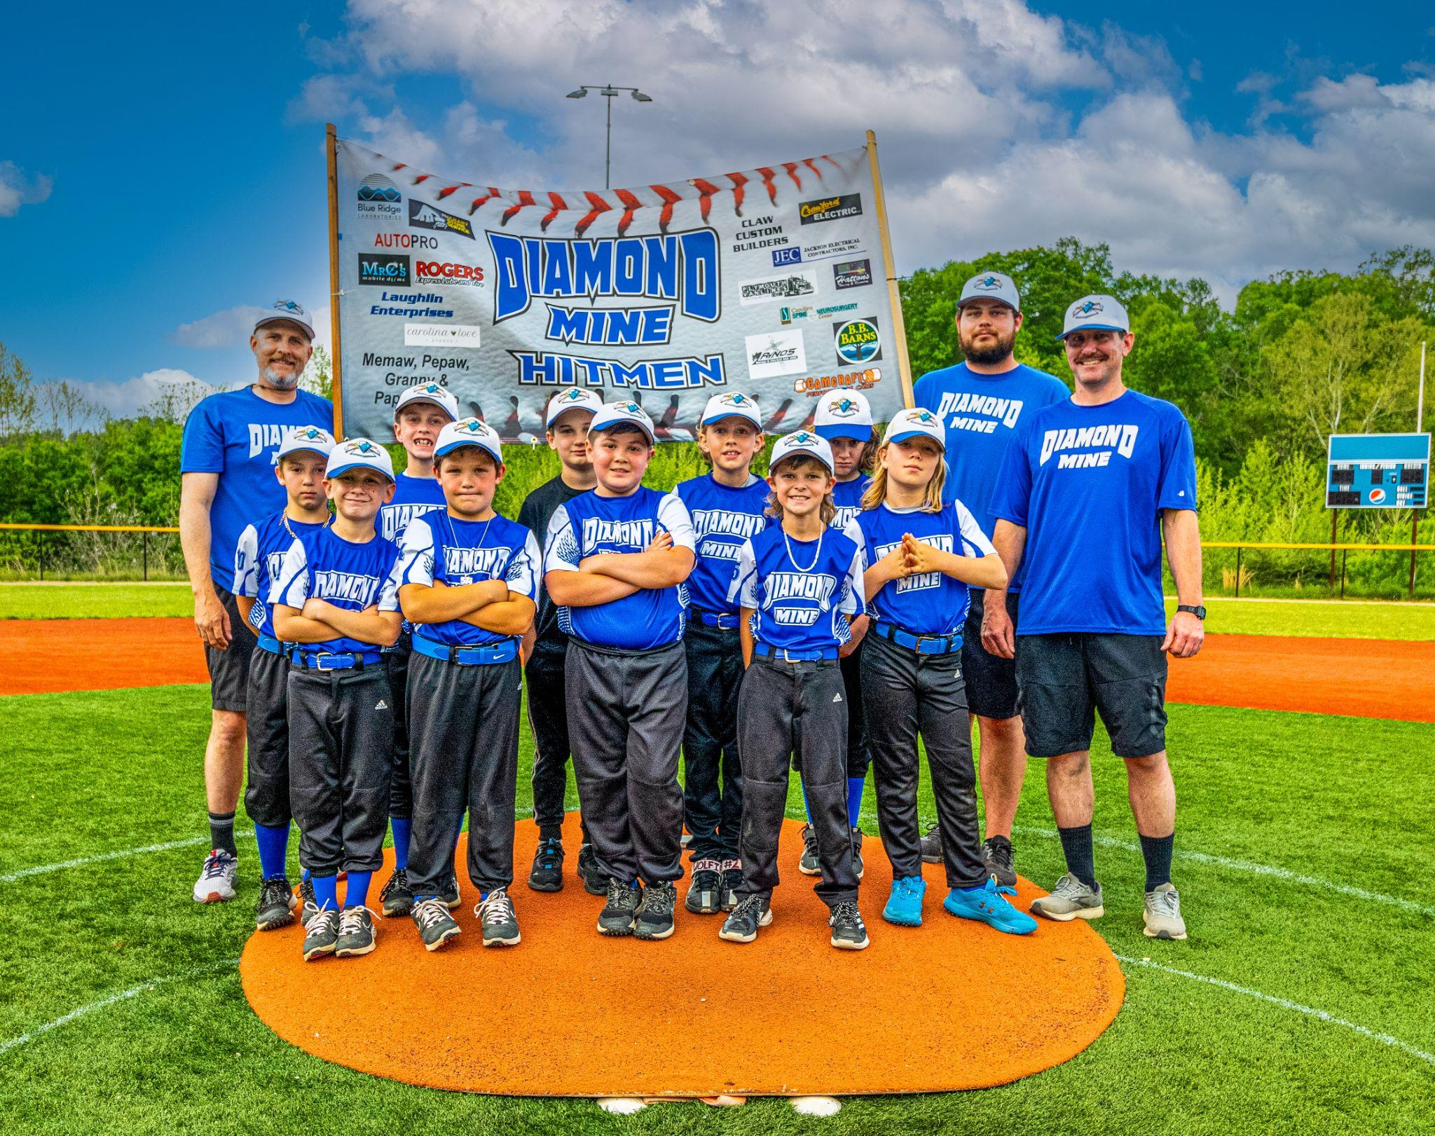
**Cannot turn 11 before 5/1/2023**

