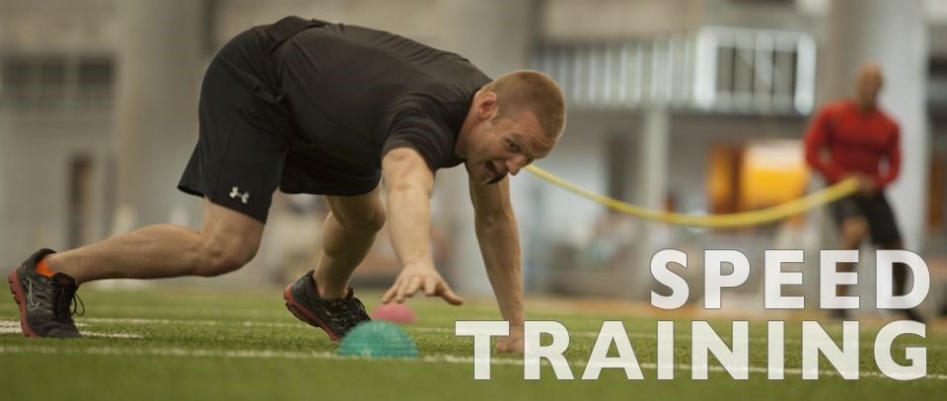

Baseball Speed, Strength and
Agility Training is Back at
The Diamond Mine!

10 Weeks of Intense Training to Improve your overall speed,
strength and agility to help you become a better athlete.

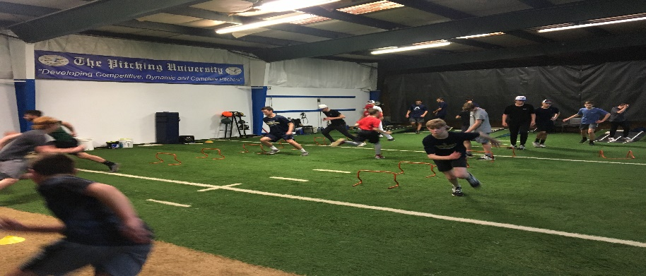
Get ready for the season with intense workouts to improve your overall athleticism!

Meets at The Diamond Mine
951 Sand Hill Rd
Asheville, NC 28806
Led by Carlos Perez with SuperFit

Starts December 3rd 2022 @ 10:00 AM & 11:00 AM
$20.00 per session

| The Diamond Mine| 828 665-7787 | dchaplain.thediamondmine@gmail.com|
thediamondmine.com

