The Diamond Mine Velocity Program | Amazing Results!
Pitching 201: The Dynamic Pitcher  Velocity Improvement for Pitchers  Want to Increase your velocity? Want to have more dynamic pitches? Sign up or this valuable 10-week intense training focused on velocity improvement that has been highly successful in developing velocity in pitchers. Athletes will need a high level of c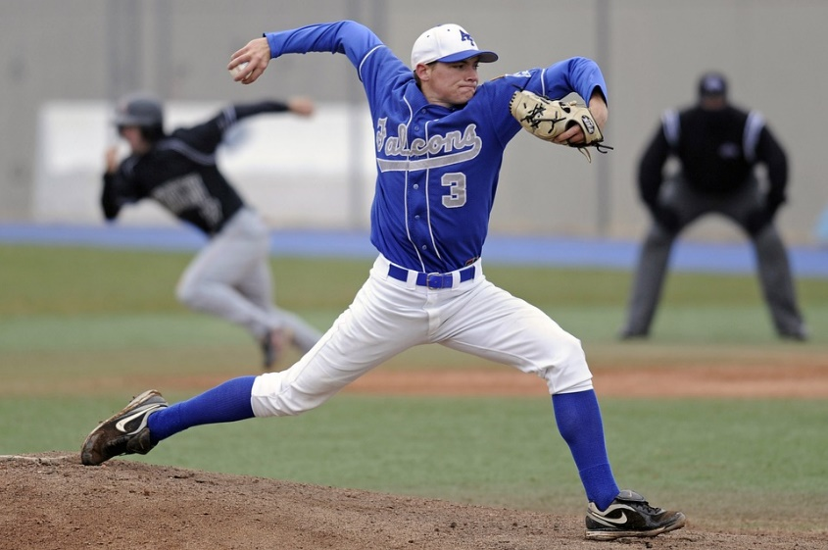om “GET INVOLVED AND IMPROVE YOUR VELOCITY” time n exercises that will increase flexibility and strength. | For More information:  Call: The Diamond Mine o  828 665-7787 (Business)  828 606-8528 (Cell)  dchaplain.thediamondmine@gmail.com

