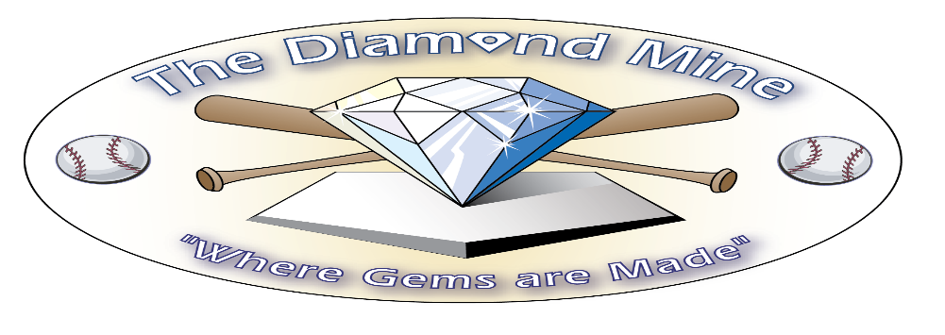
Speed, Strength and Agility Boot Camp is Here!
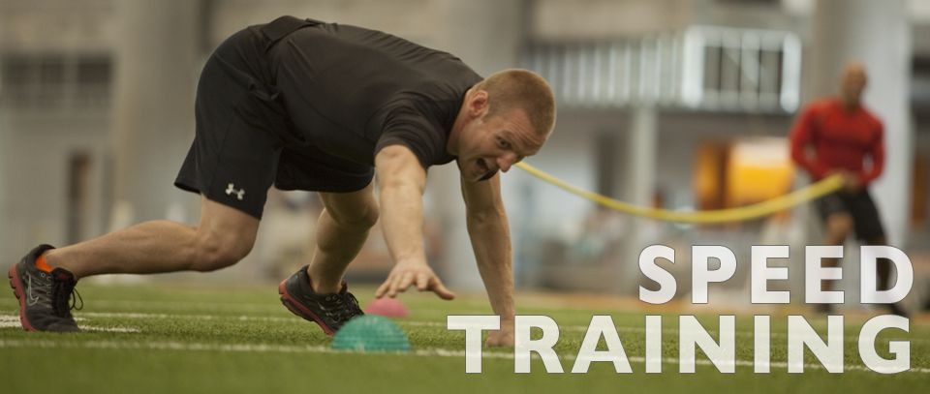
10 Weeks of Intense Training to Improve your overall speed, strength and agility to help you become a better athlete.
Boot Camp Every Saturday starting January 16th, 2021
^{10:00 AM or 11:00 AM}
Get ready for the season with intense workouts with Carlos Perez to improve your overall athleticism!
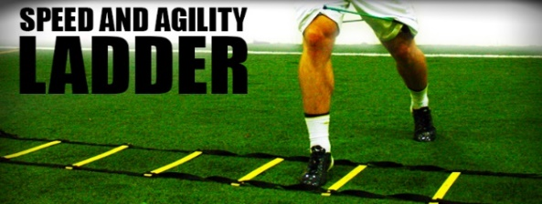
Meets at The Diamond Mine
951 Sand Hill Rd Asheville, NC 28806
The Diamond Mine| 828 665-7787 | dchaplain.thediamondmine@gmail.com|
thediamondmine.com

